참고사이트: <https://www.flo-design.eu/accessible-travel>

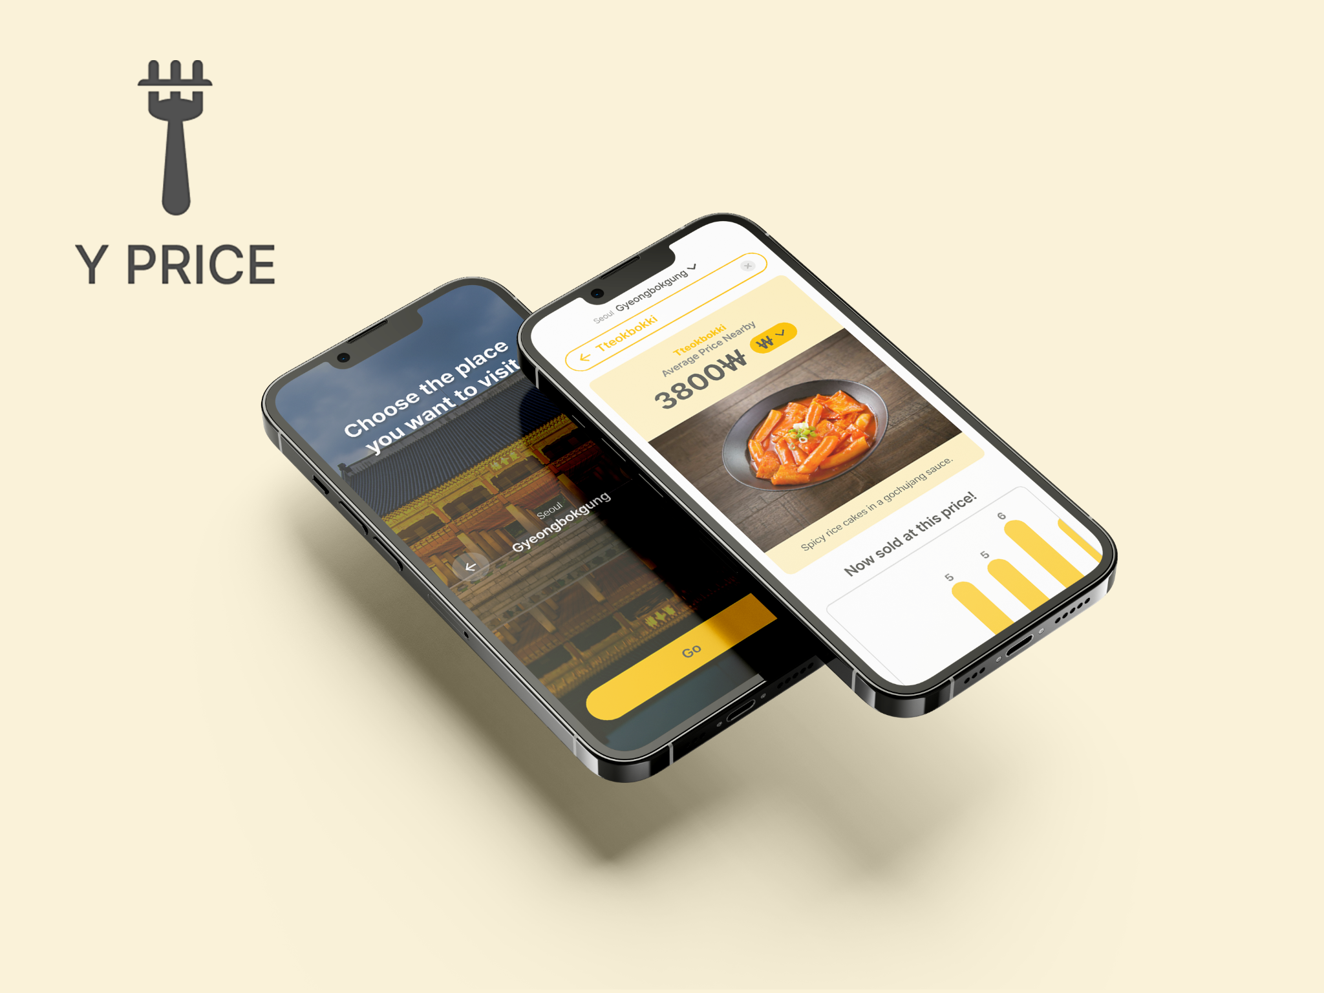

**Project 2: YPrice**

부제: Reducing the "Cost and Currency Difference" Problem

Project Brief: YPrice is a service designed to assist travelers by offering information on the average prices of Korean cuisine. This service is dedicated to reducing the worries associated with "food" and "cost" that pose significant challenges for travelers. By providing transparent and reliable pricing data, YPrice helps visitors plan their meals and budgets more effectively, ensuring a more enjoyable travel experience in Korea.

Project Type: University Capstone Project

Timeline: March, 2023 - June, 2023 (3 months)

Tools : Figma, FigJam

Skills: Competitive Analysis, User Personas, Scenario, Wireframe

Team: 2 UX Designer, 3 Frontend developers, 2 Backend developers

Role: UX Designer

————————————————————————— 구분선

Contents

**1. User Research (버튼)**

**2. UX Design (버튼)**

**3. Usability Test (버튼)**

**4. Project Prototype (버튼)**

**5. Key Takeaways (버튼)**

————————————————————————— 구분선

**How it all started**

This project was an international collaboration with students from the Netherlands, conducted entirely online. To facilitate seamless communication, we used Google Docs, Microsoft Teams, and KakaoTalk.

Our goal was to tackle issues affecting young people today.

To understand these challenges, we explored several questions:

What concerns do ***youth*** in Korea and the Netherlands have?

What's the biggest difference between these two places for the ***youth***?

What big changes or trends in the world are affecting the ***youth***?

From our discussions, we found two keywords: "Money" and "Travel." These themes were both related and conflicting, as traveling often requires a budget.

Understanding the Dutch students' interest in visiting Korea, our project specifically targeted the aspect of "traveling to Korea."

————————————————————————— 구분선

**1. User Research (버튼)**

**Research Goals**: We want to explore the significance of food for visitors to Korea. We aim to understand factors such as their preferences, existing services, and budget considerations.

**Methodologies:**

1) Competitive Analysis

2) User Interview

#### **Competitive Analysis**

|  | Yelp | Diningcode | TripAdvisor |
| --- | --- | --- | --- |
| Picture |  |  |  |
| Target market | Worldwide - Residents looking for places to eat, and businesses seeking to advertise. | South Korea - Residents searching for restaurants. | Worldwide - Travelers seeking information on accommodations, restaurants, attractions, and activities. |
| Strengths | - Vast database of businesses across numerous categories and regions  - Has both a mobile app and a website | - Personalized recommendations  - Recommend dating ideas for couples | - Allows users to book via app or website  - Has both a mobile app and a website  - A large volume of user-generated reviews |
| Weakness | - Questionable review authenticity | - Focused on other marketing such as blog postings | - Users may be overwhelmed with vast choices in other categories |
| Features | —--------------- | —--------------- | —--------------- |
| Multilingual Support | V | V | V |
| Location-Based Discovery | V | V | V |
| Currency Support | X | X | V |
| User Review | V | V | V |
| Restaurant Information | V | V | V |

1. **User Interview**

4 people were interviewed. For our research, we focused on ***foreigners living in Korea***, specifically targeting individuals in their 20s. We chose ***three exchange students*** studying at Hankuk University of Foreign Studies. These students were interviewed in person, and I utilized Speech-to-Text (STT) tools to accurately transcribe the conversations.

The interview was divided into two parts.

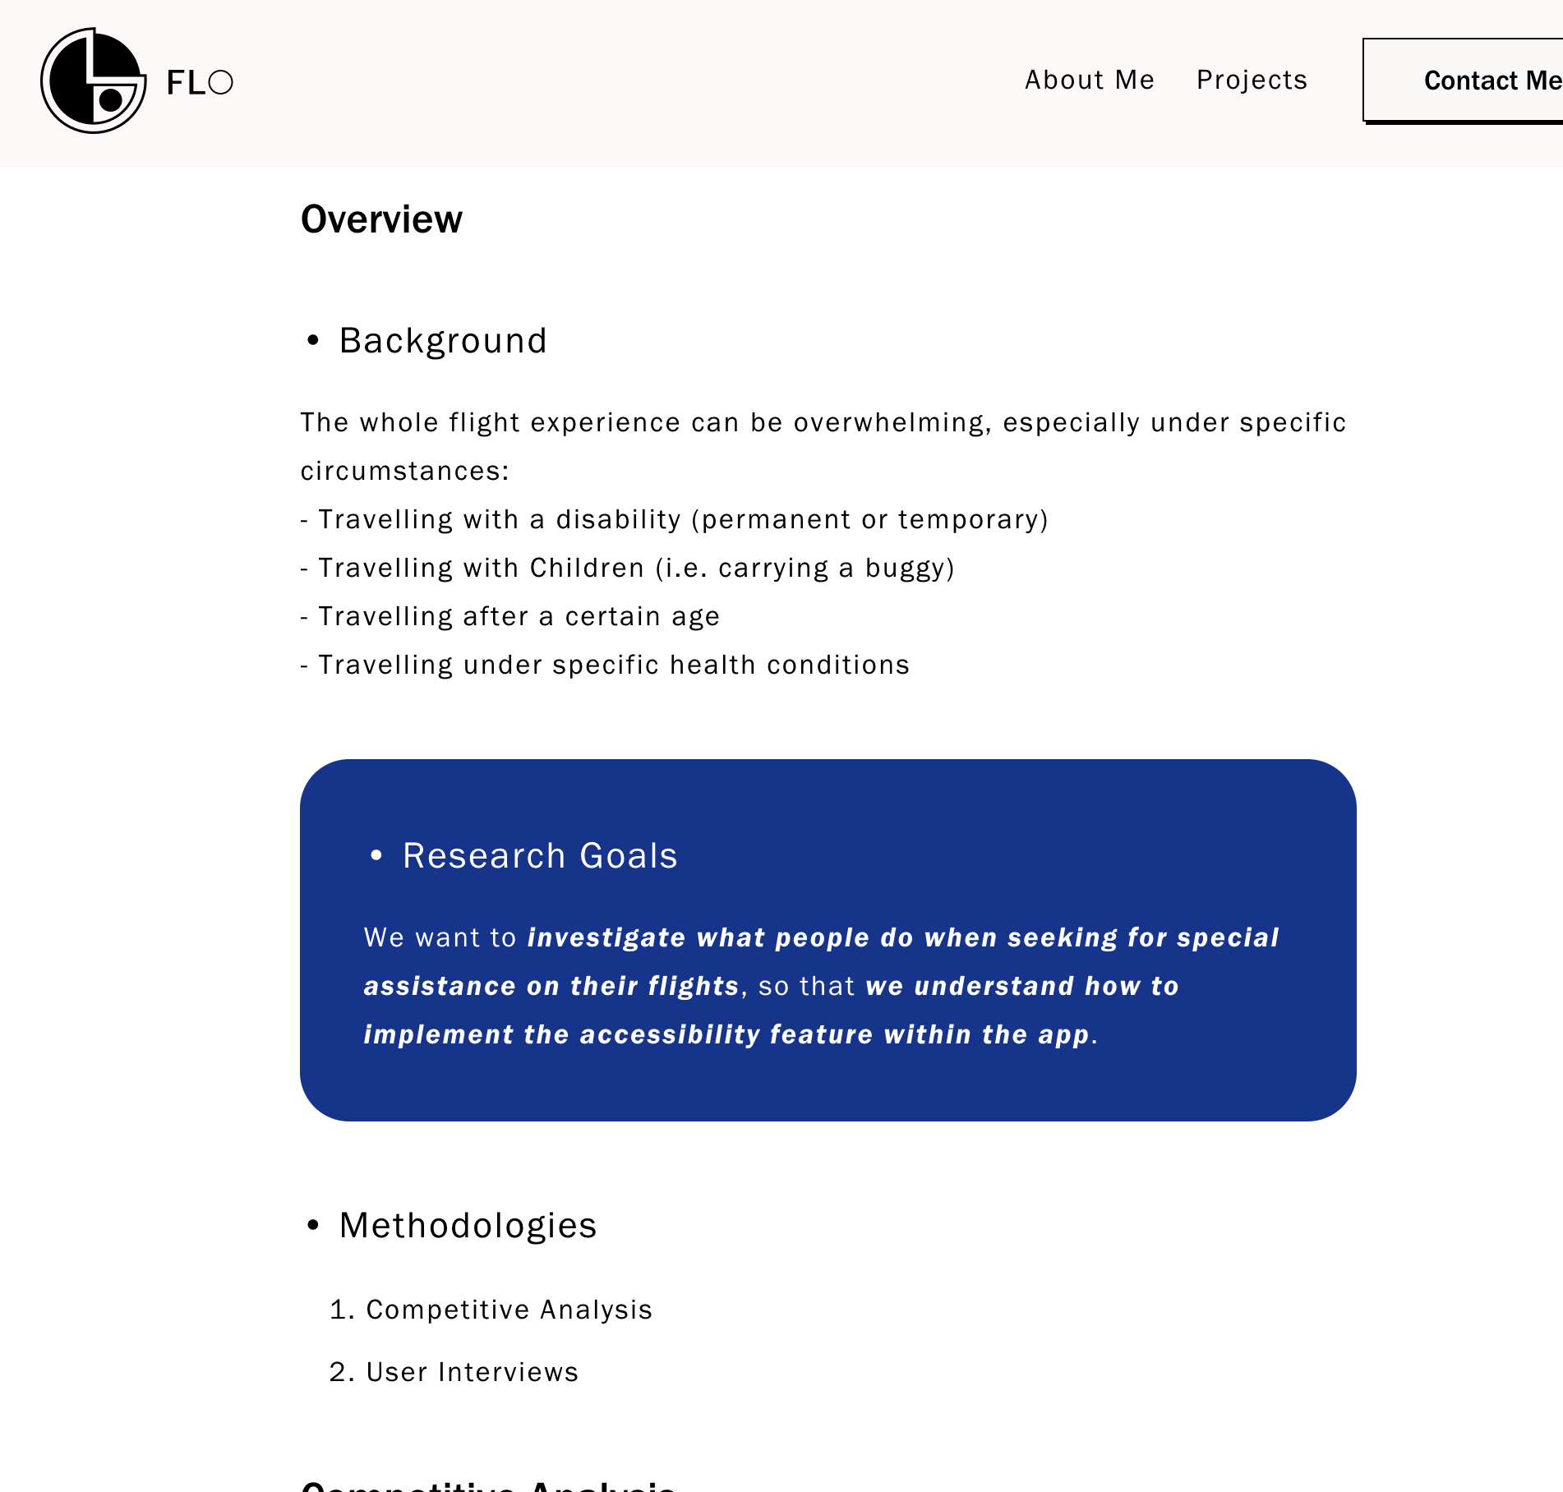

ㄴ Part 1, Part 2 파트 별로 따로 색깔 구분하기

Part 1: General Questions

What are your main reasons for traveling to Korea?

How important is food to your travel experience? Rate 1-10

How do you currently find information about Korean restaurants and food?

What types of Korean cuisine are you most interested in trying?

What is your budget for food while traveling in Korea for a week?

Have you ever used a service that provides information on local food prices before?

Would you use a service that provides information on local Korean food prices?

Part 2: Prototype Questions

What features do you look for in a service that provides information on local food prices?

What types of information would you like to see in the service?

How important is the accuracy of the pricing information to you?

How often would you use the service?

What do you think would be the biggest benefit of using a service that provides information on local Korean food prices?

Is there anything else you would like to add about your interest in Korean cuisine or this type of service?

**Affinity Mapping:**

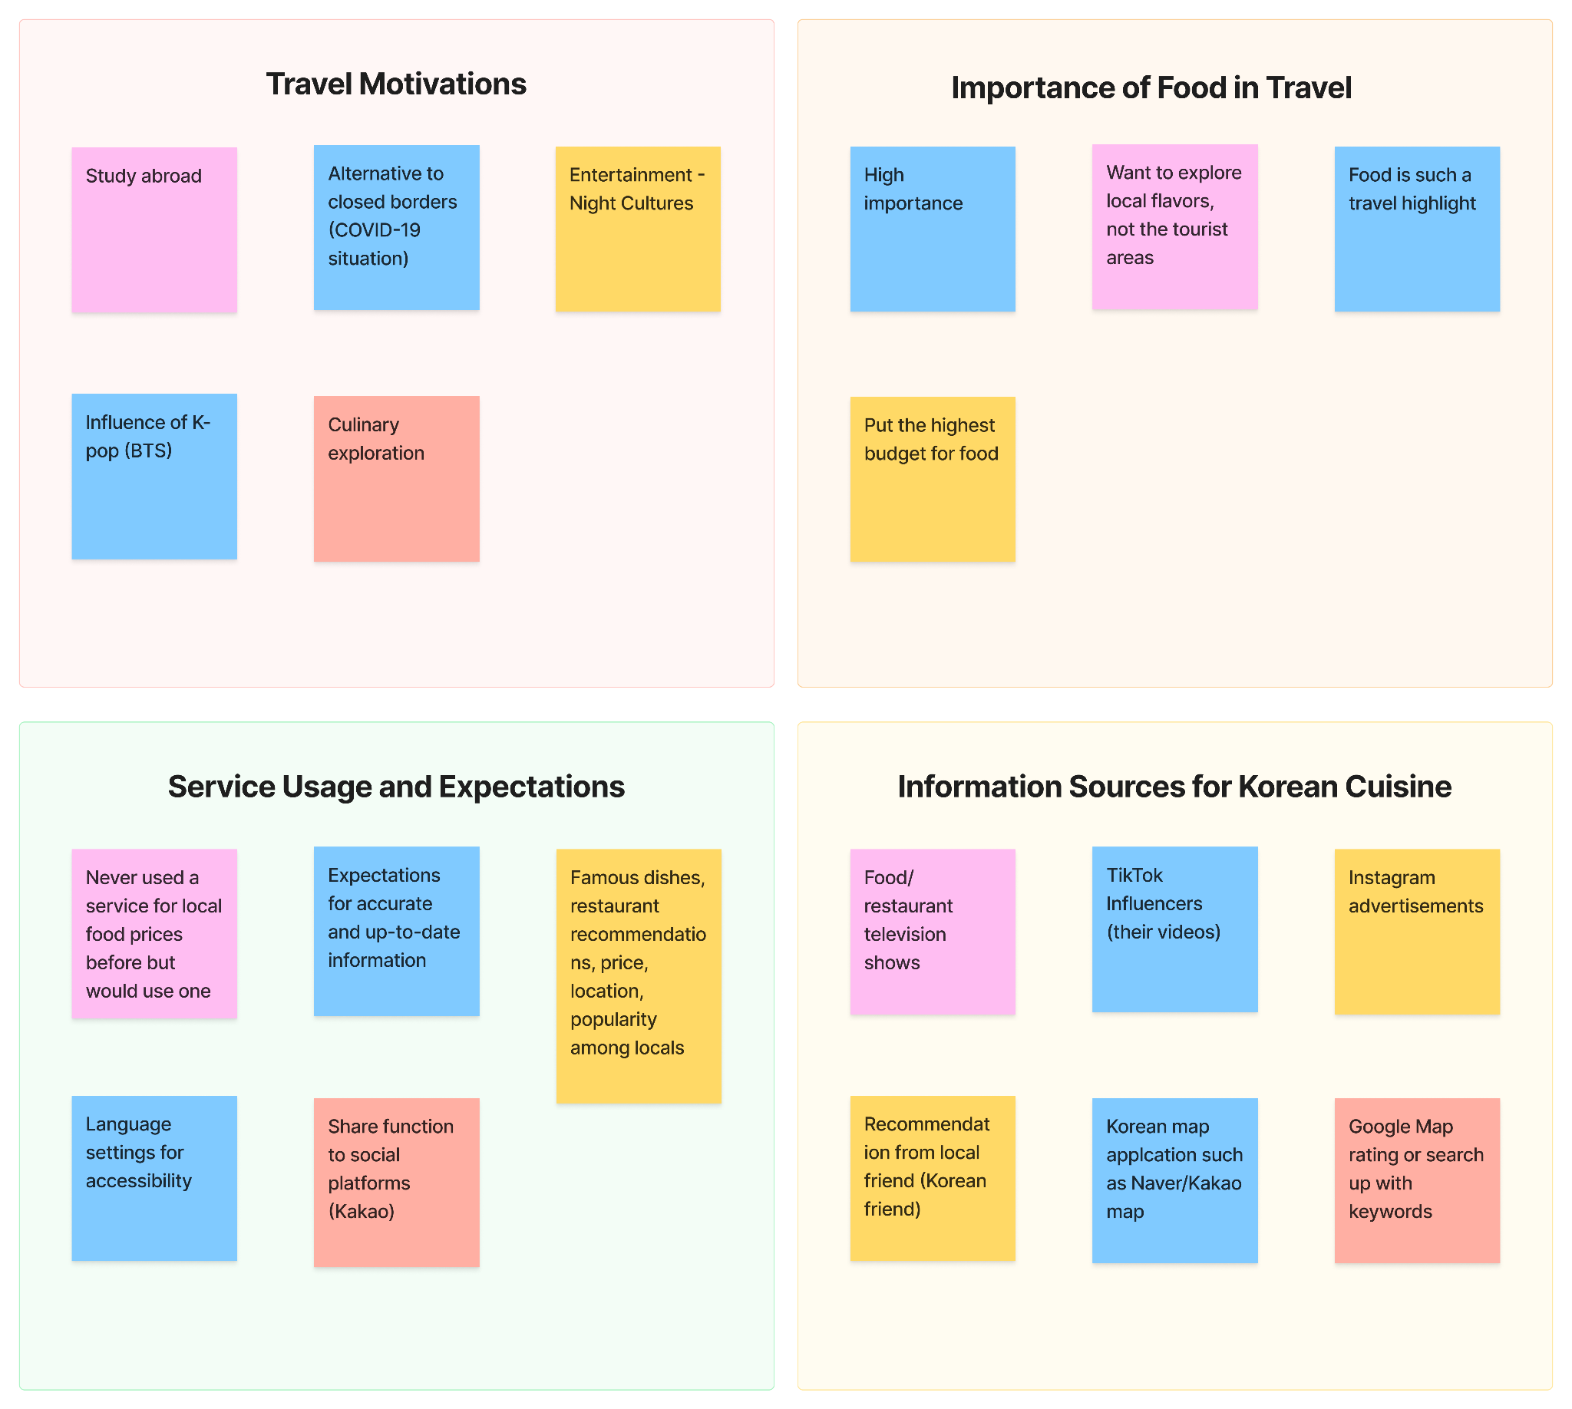

#### **Research Findings**

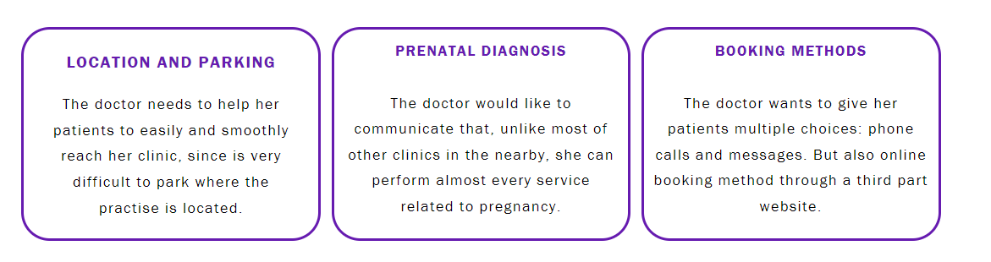

**!메모 디자인 - 이렇게 여러개 가로 배열**

1. Importance of Food

Participants rated the importance of food in their travel experience with an average score of 9 out of 10, demonstrating a high interest in Korean cuisine in travel.

2. Attitudes Toward Food

Participants expressed a desire for affordable dining options that are popular among locals, avoiding overly tourist-centric spots for authentic experiences.

3. Desired Features for Future Services

Participants highlighted the need for features such as multilingual support (especially for European users) and extensive regional coverage to enhance accessibility and convenience.

4. Utilization of Map Application

Participants frequently used map applications like Google Maps, Naver Maps, and Kakao Maps not only for checking restaurant ratings but also for discovering by using keywords (e.g., "Chinese food") or by exploring through map icons.

**Personas (메모: 특정 사람 사진 필요)**

**User Persona #1**



ㄴ 파일명: jenny.jpg

Name: Jenny Patel

22 Y/O - UNIVERSITY STUDENT

Personality: Curious, Rational

Hobbies: Traveling, Listening to music

Quote: "I'm eager to explore the Korean food I have seen from Mukbang and I am planning to travel to Korea."

Bio: Jenny is a New York University student. She has developed a keen interest in Korean dishes. Her interest began after watching Mukbang on YouTube, which showcased the diverse Korean food culture. Therefore Jenny plans to travel to Korea during summer. Jenny is excited about her first trip to Korea but concerned about the costs, as she's unfamiliar with the language, currency, and living expenses there. However, Jenny faces challenges in her preparation. Searching for restaurants online, she has encountered prices in Korean won—a currency she is not familiar with. Her goal is to experience a wide range of Korean foods without exceeding her budget.

Goals:

- To easily explore the adequate price of Korean food

- To accurately estimate food costs for budget-friendly travel.

Frustrations:

- Being unfamiliar with Korean currency and living expenses.

- Facing language barriers and navigation challenges.

**User Persona #2**



**ㄴ 파일명: chloe.jpg**

Name: Chloe Rodriguez

20 Y/O - UNIVERSITY STUDENT

Personality: Reasonable, Friendly

Hobbies: Traveling, Photography

Quote: "While living in Korea which is a country I always wanted to come to, I want to eat the delicious food I wanted to try, but at the same time I want to be reasonable with my spending."

Bio: Chloe is an exchange student from Turkey currently living in Korea. Her interest in K-pop and Korean culture brought her here. As she navigates her life abroad, Chloe regularly checks her bank account. She becomes increasingly aware that food is her largest expense. Determined to manage her budget, she seeks out affordable restaurants that don't compromise on quality. Yet, Chloe also desires to explore the famous Korean cuisine she's longed to experience, striving to find a balance between trying delicious dishes and keeping her spending within her budget.

Goals:

- To easily compare the price of food compared to the average price.

- To discover budget-friendly food that is famous.

Frustrations:

- Difficulty finding information on average meal prices in her area, making it hard to know if she's spending wisely.

- Balancing her desire to explore Korean cuisine with the need to adhere to a strict budget

————————————————————————— 구분선

**2. UX Design (버튼)**

**Requirements Matrix**

Based on insights from three distinct user personas identified during our user research, I have developed a requirements matrix to move on to the UX design phase.

| **Priority** | **Persona** | **Description** | **Data Needs** | **Functional Needs** | **Product Quality** | **Constraints** |
| --- | --- | --- | --- | --- | --- | --- |
| 1st | Jenny Patel | Wants to explore the adequate price of Korean food | 1) Current exchange rates  2) Menu prices across different regions | - Currency converter  - Filters for cuisine type, price range | - User-friendly interface  - Accurate data  - Clear, concise menu translations | - Must accommodate users unfamiliar with Korean currency, Won |
| 2nd | Chloe Rodriguez | Wants to compare food prices to find budget-friendly options | 1) Average meal prices in specific areas | - Comparison tool for prices | - Quick, accessible comparisons | - Needs to be mobile-friendly |

**Product Roadmap**

**Feature Discovery**

After having established the requirement matrix, everyone in our team has listed the different features on the FigJam that we wanted to include on the website.

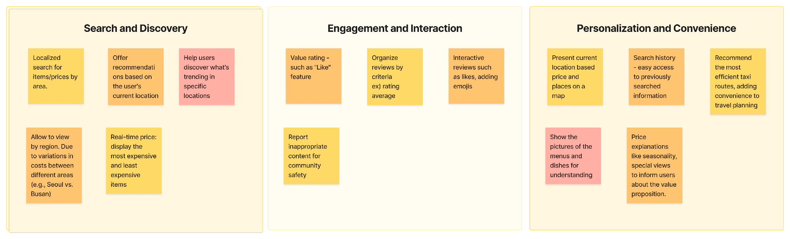

Then prioritized them into a spreadsheet. All the decisions have been supported by user interviews and comparative analysis.

|  | Feature Name | Description | Supporting Research |
| --- | --- | --- | --- |
| P1: Must Have | Location-Based Discovery | Discover places and prices in specific regions. | User interview, comparative analysis |
|  | Currency Support | Convert prices into the user's currency. | User interview, comparative analysis |
|  | User Review | Share and read reviews of places. | User interview, comparative analysis |
|  | Restaurant Information | Access detailed info about restaurants. | Comparative analysis |
|  | Food Search | Find specific dishes in the area. | Comparative analysis |
|  | Restaurant Search | Search for restaurants by name. | Comparative analysis |
|  | Average Price | Support average price according to the same dish in the region. | User interview |
| P2: Nice to Have | Trending Dishes | Show popular dishes nearby. | Comparative analysis |
|  | Menu Pictures | Show pictures of menus and dishes to help with decision-making | Feature discovery, user interview, comparative analysis |
|  | Map-Based Display | Present current location-based prices and places on a map | Feature discovery, comparative analysis |
| P3: Surprising and Delightful | Multilingual Support | Support multiple languages for accessibility. | User interview, comparative analysis |
|  | Price Explanations | Provide reasons for high prices, like seasonality or special views | Feature discovery |
|  | Cultural Insight | Provide cultural dining tips. | User interview |
| P4: Can come later | Seasonal Recommendations | Highlight seasonal food recommendations. | User interview, feature discovery |
|  | Real-Time Price Trends | Display the most expensive and least expensive items in real-time | Feature discovery |
|  | Efficient Taxi Routes | Recommend the most efficient taxi routes to destinations | Feature discovery |
|  | Inappropriate Content Report | Offer the ability to report inappropriate content or reviews | Feature discovery, comparative analysis |

#### **Information Architecture**

Guided by the product roadmap, we have decided to start designing from P1: Must Have to P2: Nice to Have. To communicate with developers, we made two different types of IA which are scenario and data structure,

1) Information Architecture - Scenario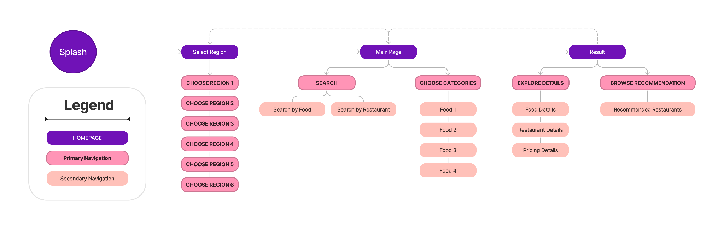

2) Information Architecture - Data

To select specific content for our service - region, and categories, we conducted additional user research with members from the Netherlands. This research was conducted using a Google Form survey.

10 participants were chosen with these criteria:



**!메모 디자인 - 이렇게 여러개 가로 배열**

1) Non-Korean nationals

2) Planning or aspire to travel to Korea

For the region, we identified ***three popular cities*** that potential travelers want to travel to in Korea: ***Seoul, Busan, and Jeju Island.*** Also, Seoul was subdivided into distinct areas which are Itaewon, Gangnam, Gyeongbokgung, and Hongdae. Haeundae area for Busan and Aewol-up for Jeju Island accordingly due to their fame.

For food, we narrowed down the ***food selection into four categories*** which are ***tteokbokki, bulgogi, bibimbap, and samgyeopsal***. This is intended to help users to spend less time exploring Korean dishes on their own. These choices are ***based on the popularity and desire that participants wish to try in Korea***.

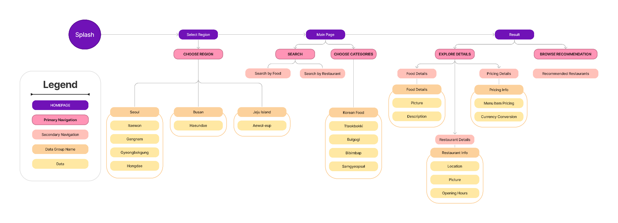

#### 

#### **User Flows**

#1 Finding the Average Price of a Dish

Splash Screen: The user opens the web service in the browser.

Select Region: The user chooses 'Seoul - Itaewon' from the list.

Main Page: The user is directed to the main page.

Choose Categories: The user browses through the list and selects 'Bibimbap'.

Food Details: The user reviews the details of 'Bibimbap' including photos and descriptions.

Restaurant Recommendations: User explores 'Recommended Restaurants' for 'Bibimbap'.

Restaurant Selection: The user chooses a restaurant based on recommendations.

Restaurant Details: The user explores the average price of 'Bibimbap' in 'Seoul - Itaewon' district.

Currency Conversion: The user utilizes the currency conversion tool to see the price in their local currency.

Plan Visit: The user decides to visit the restaurant and notes down the details.

#2 Comparing Restaurant Prices

Splash Screen: The user opens the web service in the browser.

Select Region: The user chooses 'Busan - Haeundae' from the list.

Main Page: The user is directed to the main page.

Search by Food: The user enters 'Bulgogi' in the search bar.

Search Results: The user reviews the search results displaying Haeundae restaurants.

Pricing Details: The user explores the average price of 'Bulgogi' in 'Busan - Haeundae' district.

Restaurant Details: The user clicks on a restaurant to view more details.

Price Comparison: The user compares the price of 'Bulgogi' at the selected restaurant with the average price.

Plan Visit: The user decides to visit the restaurant and notes down the details.

**Task Flow**

Estimating Meal Cost for a Day in Hongdae

Splash Screen: The user opens the web service in the browser.

Select Region: The user chooses 'Seoul - Hongdae' from the list.

Main Page: The user is directed to the main page.

Choose Categories: The user browses through the list and selects 'Tteokbokki'.

Pricing Details: The user explores the average price of 'Tteokbokki' in 'Seoul - Hongdae' district.

Budget Planning: The user uses the average price information to estimate their meal budget for a day.

Currency Adjustment: The user adjusts the currency settings if necessary to see the prices in their preferred currency.

Plan Completion: The user finalizes their daily meal cost estimate in the budget.

#### 

**UI Design**

**Logo**



For our project's logo, we combined a fork and the Korean Won symbol. The fork represents utensils for eating, and the Korean Won denotes South Korea's currency, which highlights the unique aspects of Korean dining culture.

#### **Wireframes**

(이미지 5개, 파일에 따로 저장되어있음)

————————————————————————— 구분선

### **3. Usability Test (버튼)**

Prototype

(이미지 11 개, proj2_proto 라는 파일에 따로 저장되어있음)

**Outcome**

The prototype has been tested on 8 participants. The age range of them was 19 to 28 y/o.

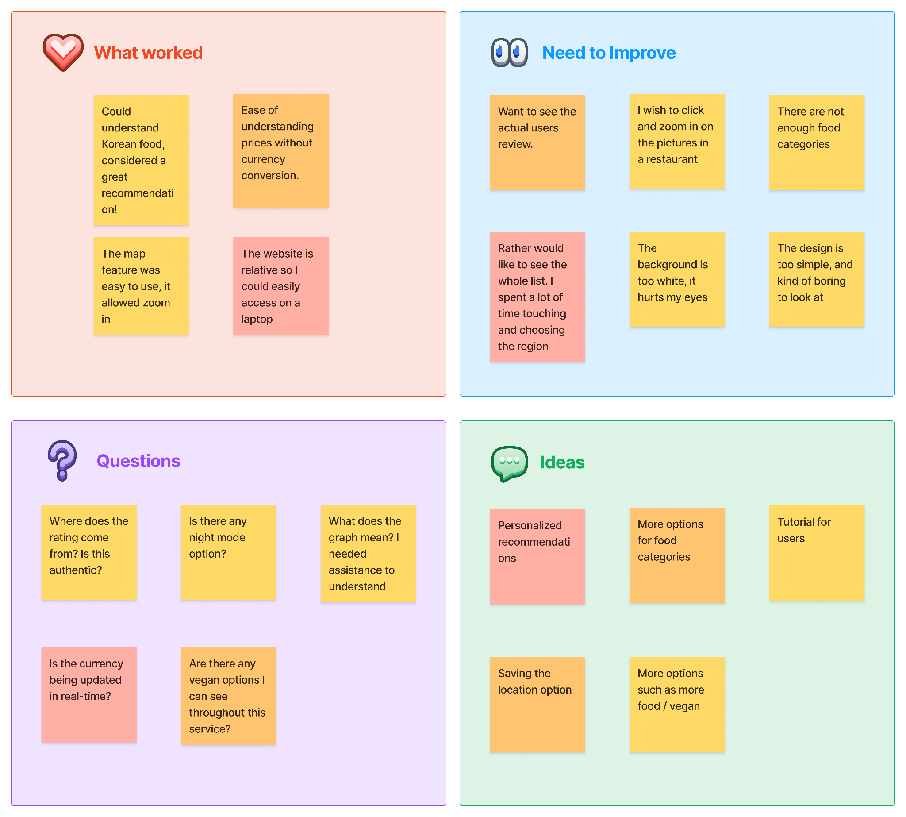

————————————————————————— 구분선

**4. Project Prototype (버튼)**



[Yprice (k-labproject1-y-price-front.vercel.app)](https://k-labproject1-y-price-front.vercel.app/)

————————————————————————— 구분선

**Key Takeaways (버튼)**

Challenge

Since the timeframe of the course was restricted, we could not add enough features such as detailed guides on enjoying Korean cuisine.

Lesson learned

Completing this project ***entirely through online meetings*** has taught me the importance of aligning every member’s understanding of the same project. Our team leveraged digital communication tools and entire weekly meetings for ***seamless collaboration***.

***Feedback from our team members in the Netherlands*** was instrumental in recognizing the need for multi-currency support. As a result, we expanded our service to include various currencies like the won, dollar, and euro, significantly enhancing ***accessibility for international users***.